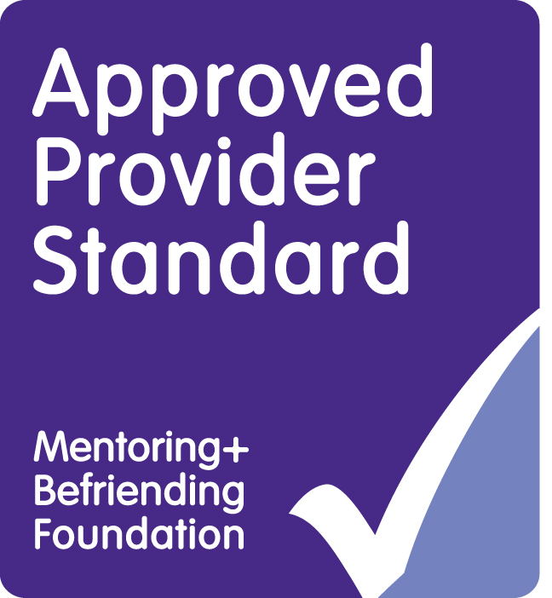 |  |  |  |  |  |  |  | Referral Form  1.Mentoring (Offending/ASB)  2.Independent Visitor (CLA)  3.Advocacy (CLA/CP)  * Circle required service |  |  |  |  |  |  |  |  |  |  |  |  |  |  |  |  |  |  |  |  |  |  |  |  |  |  |  |  |  | 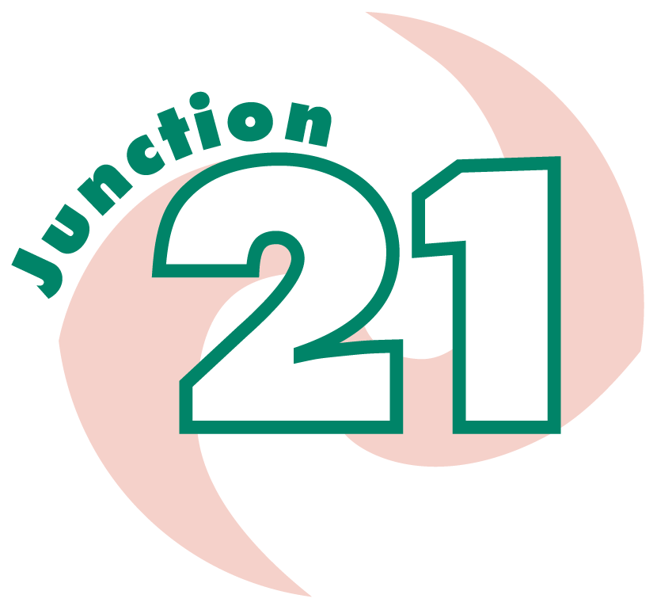
Referrer details |  |  |  | Name: |  |  |  |  |  |  |  |  |  |  |  |  |  |  |  |  |  |  |  |  |  |  |  |  | Agency (if applicable):
Address: |  |  |  |  |  |  |  |  |  |  |  |  |  |  |  |  |  |  |  |  |  |  |  |  |  |  |  |  | Telephone No:
 |  |  |  |  |  |  |  |  |  |  |  |  |  |  |  |  |  |  |  |  |  |  |  |  |  |  |  |  | E-mail:
Child details |  |  | Name: |  |  |  |  |  |  |  |  |  |  |  |  |  |  |  |  |  |  |  |  |  |  |  | Other Names: |  |  |  |  |  |  |  |  |  |  |  |  |  |  | Male |  |  |  |  | Female
Address: |  |  |  |  |  |  |  |  |  |  |  |  |  |  |  |  |  |  |  |  |  |  |  |  | Home Telephone: |  |  |  |  |  |  |  |  |  |  |  |  |  |  |  |  |  | DOB:
 |  |  |  |  |  |  |  |  |  |  |  |  | Post-code: |  |  |  |  |  |  |  |  |  |  |  | Mobile Telephone: |  |  |  |  |  |  |  |  |  |  |  |  |  |  |  |  |  | Age:
White |  |  |  |  | Black/Black British |  |  |  |  |  |  |  |  |  |  | Asian/Asian British |  |  |  |  |  |  |  |  |  | Chinese/Other Ethnic |  |  |  |  |  |  |  |  |  |  | Mixed
British |  |  |  |  | Caribbean |  |  |  |  |  |  |  |  |  |  | Indian |  |  |  |  |  |  |  |  |  | Chinese |  |  |  |  |  |  |  |  |  |  | White/Black Caribbean
Irish |  |  |  |  | African |  |  |  |  |  |  |  |  |  |  | Pakistani |  |  |  |  |  |  |  |  |  | Any Other |  |  |  |  |  |  |  |  |  |  | White/Black African
Other White |  |  |  |  | Other Black |  |  |  |  |  |  |  |  |  |  | Bangladeshi |  |  |  |  |  |  |  |  |  |  |  |  |  |  |  |  |  |  |  |  | White/Asian
 |  |  |  |  |  |  |  |  |  |  |  |  |  |  |  | Other Asian |  |  |  |  |  |  |  |  |  |  |  |  |  |  |  |  |  |  |  |  | Other mixed
PREFERED LANGUAGE (other than English): Interpreter required?
Does the chid have any disabilities or health needs? |  |  |  |  |  |  |  |  |  |  |  |  |  |  |  |  |  |  |  |  |  |  |  |  |  |  |  |  |  |  |  |  |  |  |  |  |  |  |  | YES |  |  |  |  |  | NO
Details
Family Details |  |  | Mother: |  |  |  |  |  |  |  |  |  |  |  |  |  |  |  |  | Father: |  |  |  |  |  |  |  |  |  |  |  |  |  |  | Foster Carer:
 |  |  | Address (if different from above): |  |  |  |  |  |  |  |  |  |  |  |  |  |  |  |  | Address (if different from above): |  |  |  |  |  |  |  |  |  |  |  |  |  |  | Address (if different from above):
 |  |  | Telephone:  Email: |  |  |  |  |  |  |  |  |  |  |  |  |  |  |  |  | Telephone:  Email: |  |  |  |  |  |  |  |  |  |  |  |  |  |  | Telephone:  Email:
Other Children in household |  |  | 1 Name: |  |  |  |  |  |  |  |  |  |  |  |  |  |  |  |  | 2 Name: |  |  |  |  |  |  |  |  |  |  |  |  |  |  | 3 Name:
 |  |  | Age: |  |  |  |  |  |  |  |  |  |  |  | M/F |  |  |  | Age: |  |  |  |  |  |  |  |  |  |  | M/F |  |  |  | Age: |  |  |  |  |  |  |  |  |  | M/F
 |  |  | Relationship: |  |  |  |  |  |  |  |  |  |  |  |  |  |  |  | Relationship: |  |  |  |  |  |  |  |  |  |  |  |  |  |  | Relationship:
 |  |  | 4 Name: |  |  |  |  |  |  |  |  |  |  |  |  |  |  |  |  | 5 Name: |  |  |  |  |  |  |  |  |  |  |  |  |  |  | 6 Name:
 |  |  | Age: |  |  |  |  |  |  |  |  |  |  |  |  |  | M/F |  |  | Age: |  |  |  |  |  |  |  |  |  |  | M/F |  |  |  | Age: |  |  |  |  |  |  |  |  |  |  |  |  | M/F
 |  |  | Relationship: |  |  |  |  |  |  |  |  |  |  |  |  |  |  |  |  | Relationship: |  |  |  |  |  |  |  |  |  |  |  |  |  |  | Relationship:
Current or previous social services involvement with any young person including Legal Status (Provide brief details)

Educational Details |  |  |  |  |  | Name of School (or other educational establishment):
Is the education placement at risk of breaking down (circle): YES NO
Main contact at school: |  |  |  |  |  |  |  |  |  |  |  |  |  |  |  |  |  |  |  |  |  |  |  |  |  |  |  |  |  |  |  | Telephone:
Does the child have learning difficulties/ communication issues? YES / NO Details:

Indicate below if young person is known to other services, give details of associated worker:
SOCIAL CARE (name)  Telephone:  Type of contact prior to ref:  Information submitted YES / NO | POLICE (name) | CAMHS (name) | OTHER – (name)
 | Telephone: | Telephone: | Telephone:
 | Type of contact prior to ref: | Type of contact prior to ref: | Type of contact prior to ref:
 | Information submitted YES / NO | Information submitted YES / NO | Information submitted YES / NO

The following factors can be associated with Risk / Vulnerability. Please circle as many factors as you believe apply to the young person being referred and provide evidence for each:

Living and Family Arrangements |  |  | Education, Training and Employment
Evidence |  |  | Evidence
Neighbourhood and Friends |  |  | Drugs/alcohol/Smoking
Evidence |  |  | Evidence
Emotional and Mental Health (Trauma) |  |  | Self-esteem or communication issues
Evidence |  |  | Evidence
Thinking, Behaviour and Attitudes |  |  | Motivation/Positives
Evidence |  |  | Evidence
CSE/CCE/County Lines |  |  | Risk/Vulnerability Young Person
Evidence |  |  | Evidence

Are you aware of any risk associated with working with this young person YES NO
Details:

Reasons for the referral for Mentor / Independent Visitor / Advocate and required outcome?

What work has your agency (if applicable) been doing with the young person to support them?

Is there further support required – Substance Advice Service, Young Victims Service, Youth Inclusion Support Project, Education Engagement Project? (Info leaflets available upon request)

Please list any upcoming reviews or meetings we would need to be aware of ?

To be completed by Junction 21: Is further info required YES NO

Any further info :

Consent form for the young person and (if required) parent/carer
Sharing Information
The Youth Offending and Prevention Service shares information on those using our services (including Junction 21) with partner agencies who constitute a part of the Youth Offending Service. Information may also be shared under other circumstances e.g. for the prevention and/ or detection of crime, for child protection purposes, for accessing relevant services to support your family and data returns to the Department of Communities and Local Government. The information stored on you will be deleted three years after the year in which the intervention is completed.

The Data Protection Act & General Data Protection Regulation Act 2018 regulates the collection, storage and use of your personal data. You have the right to see all information held on you. Please ask if you want to see any information or if you have any questions about this. The information you provide will be stored securely on computer databases called CHILDVIEW and LCS. Some of your personal information may be used for national monitoring by the Youth Justice Board (YJB) or North Somerset Children and Young Peoples Service via these databases; however, this will not include any identifiable information. Junction 21 will keep what you tell us confidential within the team.

Sometimes we need to talk to other workers or agencies about what you tell us because it helps us to help you. Junction 21 has a duty to pass on information if they know anything about you being at risk of harm to yourself or to others. We will gather further consent with you regarding which agencies you consent for us to share information with when we first meet with you. We will only contact organisations that you agree to. You may change your mind at any time, although this may affect our ability to ensure that the relevant support is provided to you and your family.
We will discuss this further with you when we start working with you.

I understand what the Substance Junction 21 is and I agree to being referred into the service. I understand the reason why the referral has been made; this has been discussed with me. This referral form has been completed in consultation with myself and (if required) my parent/ carer. I understand that the support package is voluntary and may involve support being offered from other services.
I understand that if the referral is accepted, I will be asked to complete project paperwork and receive a home visit to discuss the service where said paperwork will be completed. I understand that Junction 21 will hold information about me and may share this in certain circumstances. I have had the opportunity to discuss what this means and consider this. I also understand I can withdraw my consent at any time.

Parent/Carer Social Worker |  | Young Person
Print Name Print Name |  | Print Name
Signature Signature |  | Signature
Date: | Date: |  | Date:

Please return referral to:
Steve Coggins
Junction 21
Central Chambers
24 – 26 Walliscote Road
Weston–Super-Mare
BS23 1UP
07776170028
Junction21@n-somerset.gov.uk

Please note, referrals will not be accepted if consent has not been obtained from the parent/ carer and young person. The young person does not have to have consent from a parent/carer if they are over 13 if they are deemed as competent according to Fraser guidelines, however we would always recommend that the referrer encourages the young person to obtain consent from their parent/ carer. Under 13s must have parental consent for all referrals

