SEND record log for Individual Children (for INCCO use)
Child’s Name |  |  |  |  |  |  |  |  |  |  | DOB |  |  | School start
Strengths
Needs
SEND Category |  |  |  |  |  | 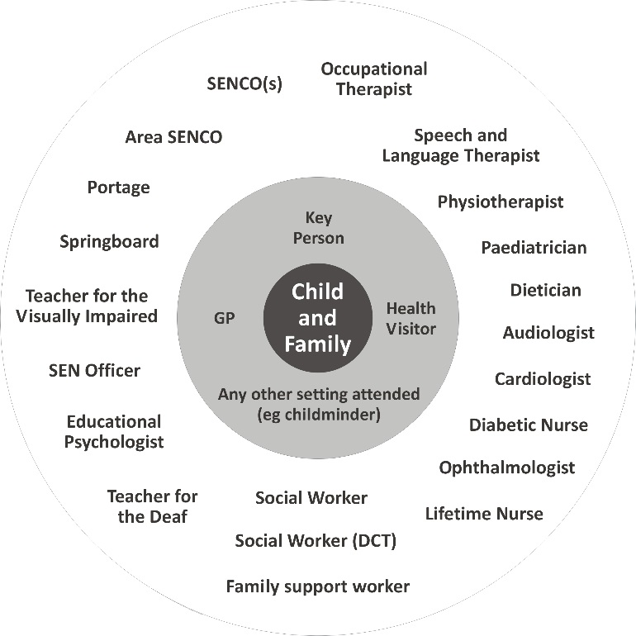  Professionals working with this child
Communication and interaction
Cognition and learning
Social, emotional and mental health
Sensory and physical needs
Placement Funding |  |  | 0-2 |  |  |  |  | 2 YO |  |  |  |  | FEE |  |  |  | 30 hours
Additional Funding |  |  | EYPP |  |  |  |  |  |  | DLA |  |  |  |  | DAF
Top up funding | Category/Level |  |  |  |  |  | Review date
Does the child have an Early Help assessment? Y / N |  |  |  |  | Date started |  |  |  | Does the child have an Education Health Care Plan? Y / N |  |  |  |  |  |  | Date issued
Other Relevant information

Record of involvement – Child Log (For INCCO use)
Date | Comment/Event

