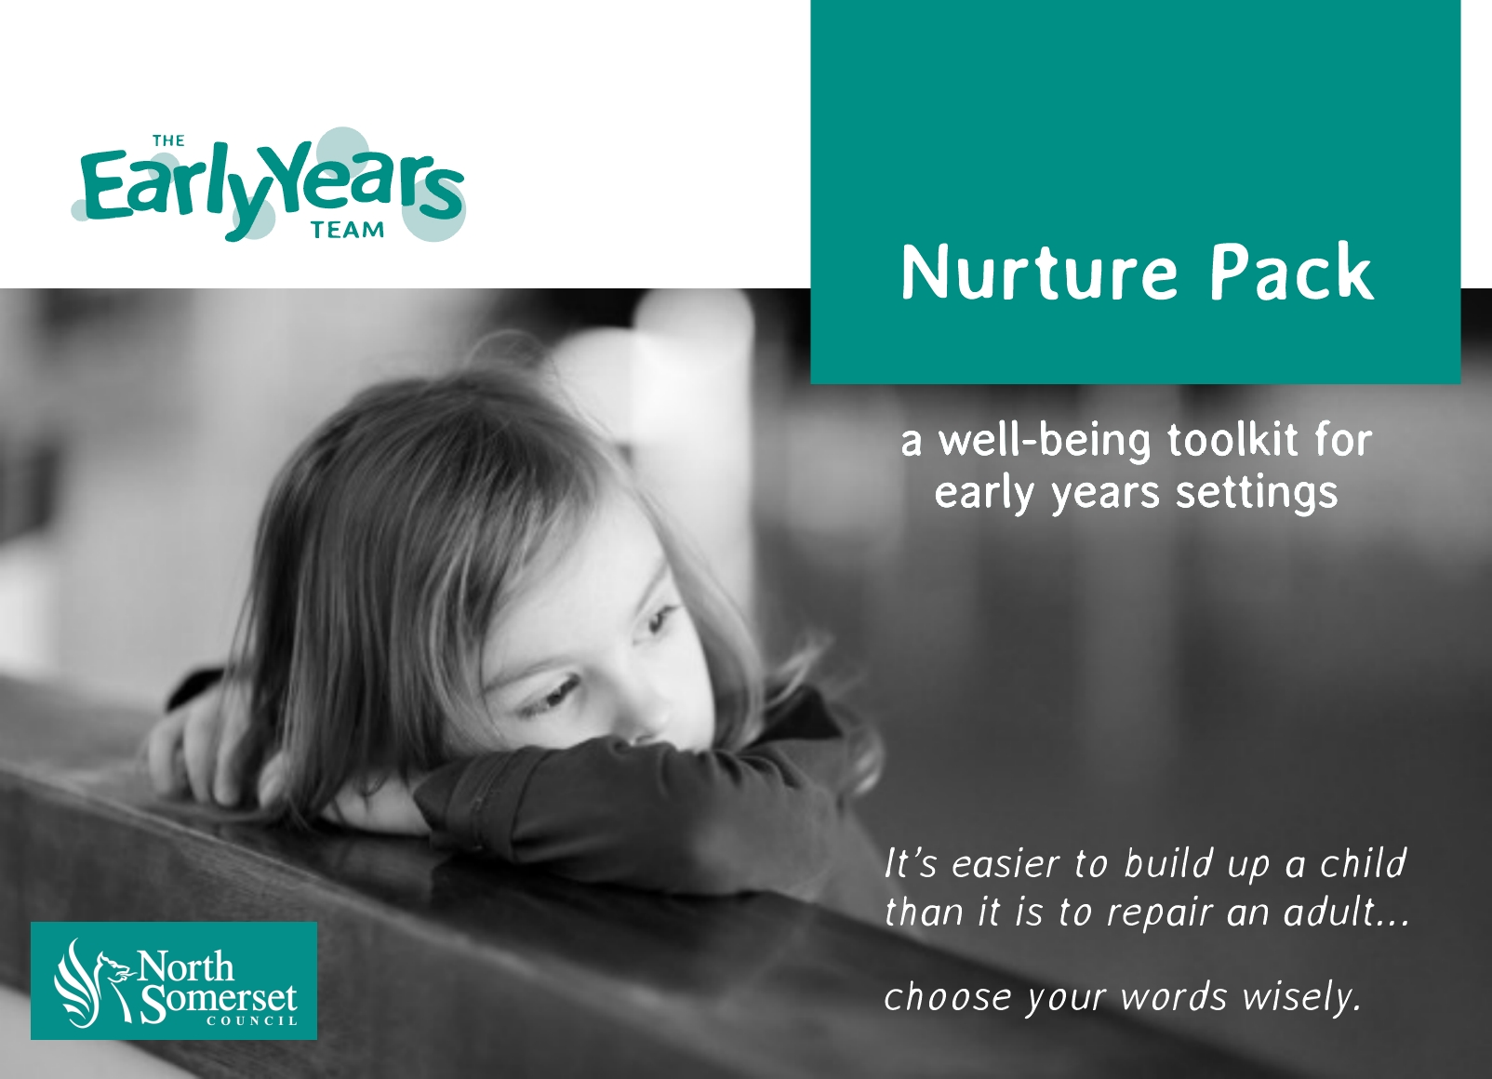

Nurture Pack Rationale

This pack has been developed to help Early Years educators identify when a child seems to have some differences with social and emotional development. These differences can often lead to high levels of anxiety that can have a negative impact on learning.
The Nurture Pack is intended for all children regardless of whether they are in receipt of top up funding. It can be used as supporting evidence for a top up funding application.
The materials in this pack are designed to support provision and progress in these cases, and to ensure maximum parental involvement and partnership working.
This Nurture Pack will enable educators to focus on the emotional and physical environment and will help them to develop strategies to support and monitor the well-being of individual children.
Please note that it is now a North Somerset Early Years Team recommendation that all Children in Care have a Nurture Pack plan in place.

Stage 1 Identifying and monitoring a child’s level of well-being
On the following page, you will find a completed example of the Identifying Social and Emotional Needs sheet. Now, with your individual child in mind, open the Identifying Social and Emotional Needs template and complete the boxes that highlight your main concerns (This should be more than one box but can be less than five).

Stage 2 Mapping concerns on the Nurture Star
The Nurture Star supports us to work with parents to map the levels of well-being in a child, and to monitor and celebrate progress and highlight where additional support is needed.
Once you have identified the five main areas of concern for the child, label the ‘arms’ of the star using the boxes provided.
In conversation with parents, plot where you feel the child is at the starting point by placing a dot on the arm. Zero is no concerns and ten most concerned.
Join up the dots with a red pen to give you a map of the starting point. Then on subsequent review dates, use a blue pen (1st review) and then a green pen (2nd review) to map the area of concern and illustrate where progress has been made.
N.B. It maybe the case that social and emotional needs increase with the second (and subsequent) reviews, and the star may increase in size before it reduces. This is to be expected for some children as they respond and react to strategies and interventions.

Stage 3 The 4 As
The 4 As is the plan that shows you have recognised that there is a need, and what you plan to do within your setting/team to support the child.
It is a whole setting approach.
Anxiety – Strategies to reduce levels of anxiety.
Attention – Strategies to meet the need for attention.
Adult – Strategies for key adults.
Area – Strategies for creating a safe place and areas.

What to do next:
- Agree on a review date.
- Share strategies with the rest of the team.
- Revisit on review date, map progress on the Nurture Star and amend the 4 As as appropriate.
Educator tip! Use the same colour pen to amend the 4 As that you have used to review your Nurture Star.
- Repeat for third cycle , and then review if still needed.

EXAMPLE 1: IDENTIFYING SOCIAL AND EMOTIONAL NEEDS

Child’s name Anna |  |  |  |  |  |  | Date 1st October 2015
Area of need |  |  |  |  | Information (continue on new page if needed)
High levels of anxiety |  |  |  | Anna has recently moved to a foster family. She has become increasingly confused, upset and displaying attachment differences at home and in the setting.
A strong need to feel in control of situations |  |  |  | She will seek adult attention constantly and will kick, hit and throw objects towards adults. Anna will crave and compete for attention from an adult especially after the adult has given attention to another child. She does not like being asked or told to do things. She finds following routines very difficult. It frustrates her not to be in control.
Delays in emotional development where their skills and abilities are similar to those of a much younger child. |  |  |  | Anna will become tearful, will scream at adults and peers, she can often throw herself to the floor when distressed.
Differences in regulating their emotions, often needing an adult to help them. |  |  |  | Anna, during every session she attends, becomes angry and upset. She does not yet have the skills to self-regulate. This means that she can hit and push adults and children.  She displays these emotions at home too. She is not yet able to express her feelings or talk with an adult about how she is feeling.
Withdrawal from certain situations through being quiet and not engaging with activities, other children or adults. |  |  |  | When distressed Anna will separate herself from other children.  Anna demonstrates that she needs to make frequent connections with adults, achieving this through affection or displaying some of the behaviours noted above.
Differences interacting with other children. |  |  |  | Although Anna’s language is age appropriate, she does not verbally communicate with other children.  Anna appears to prefer the company of adults.  Children will often avoid her and seem wary of unpredictable emotional outbursts.
Hypervigilance, constantly looking around at what is going on in the setting without being able to properly settle to an activity. |  |  |  | Anna is regularly observed being very aware of what the other children are doing and how they are interacting with adults. She will quickly intervene to connect with the adults, attempting to take their attention away from the other children.
A poor sense of self, not feeling positive about themselves or their achievements. |  |  |  | Anna does not acknowledge praise given by an adult, she does not smile, laugh or appear happy.  If Anna paints a picture or builds a tower she will often destroy it.
Other |  |  |  | Complex and traumatic circumstances appear to have impacted on Anna’s emotional well-being.

5 concerns have been identified for Anna and mapped on a Nurture Star below.

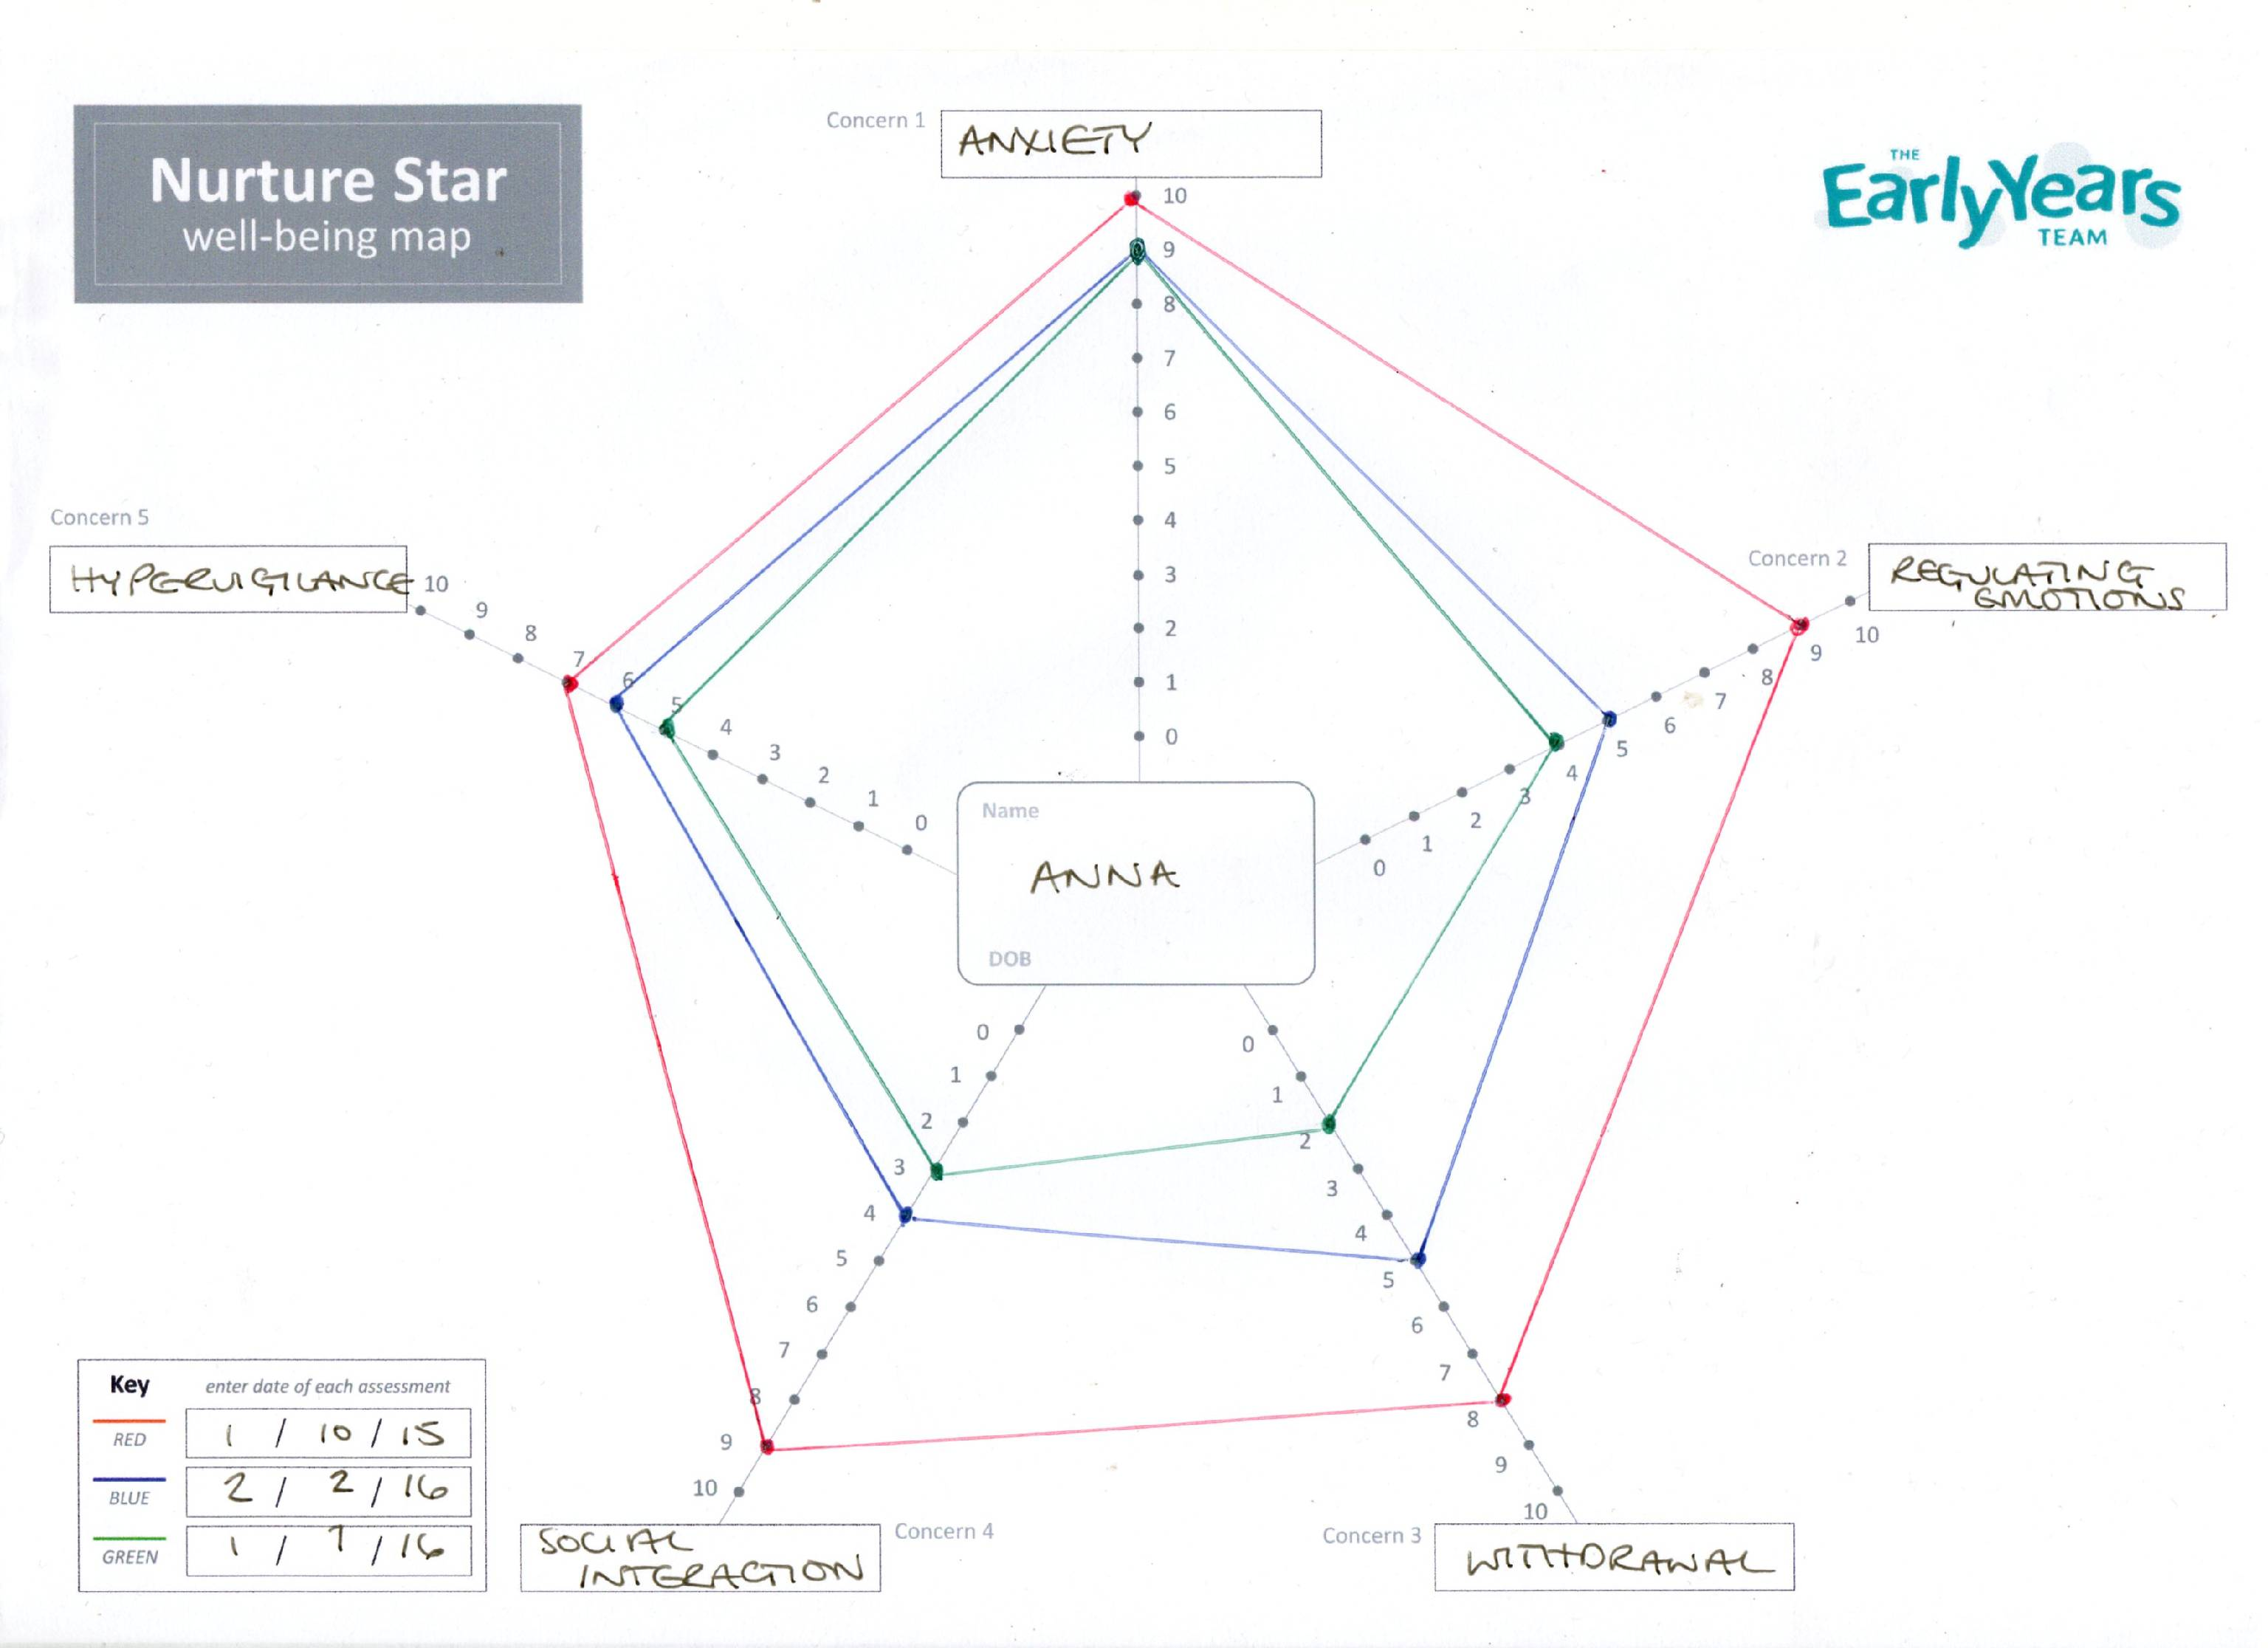

EXAMPLE 3 ANDREW: IDENTIFYING SOCIAL AND EMOTIONAL NEEDS

Child’s name Andrew |  | Date 1st October 2014

Area of need | Information (continue on new page if needed)
High levels of anxiety | Andrew gets anxious when coming into setting when other children are already there. He will stand by the door, fiddle with his fingers and look around the room for familiar adults.
A strong need to feel in control of situations | When playing in a small group Andrew can often try to take charge of the play, by instructing other children how and what to play with.
Delays in emotional development where their skills and abilities are similar to those of a much younger child. | When Andrew is upset or anxious he cannot explain why. He often says, “ I’m tired” or, “too loud’.
Differences in regulating their emotions, often needing an adult to help them. | Andrew requires an adult to co-regulate alongside when he is upset. Otherwise, he will cry for prolonged periods.
Withdrawal from certain situations through being quiet and not engaging with activities, other children or adults. | Andrew retreats to his ‘safe’ space. This is usually in the corner on the cushions by the books.  Sometimes he will seek out a chosen adult for comfort.
Differences interacting with other children. | Andrew prefers the company of adults.  Andrew will only play alongside other children if that play is supported by adults.
Hypervigilance, constantly looking around at what is going on in the setting without being able to properly settle to an activity. | Andrew will startle if he hears loud noises, such as, another child screaming or crying. He does not like the noise of the hand dryer in the toilets.  Andrew’s mother reports that at home he ‘panics’ about the hoover or some TV programmes.
A poor sense of self, not feeling positive about themselves or their achievements.
Anxiety during periods of transition. | During transitions Andrew will try to hide in his safe space. Sometimes he will cry if he is not sure what is happening next.
Other

5 points have been chosen to go on Andrew’s Nurture Star below.
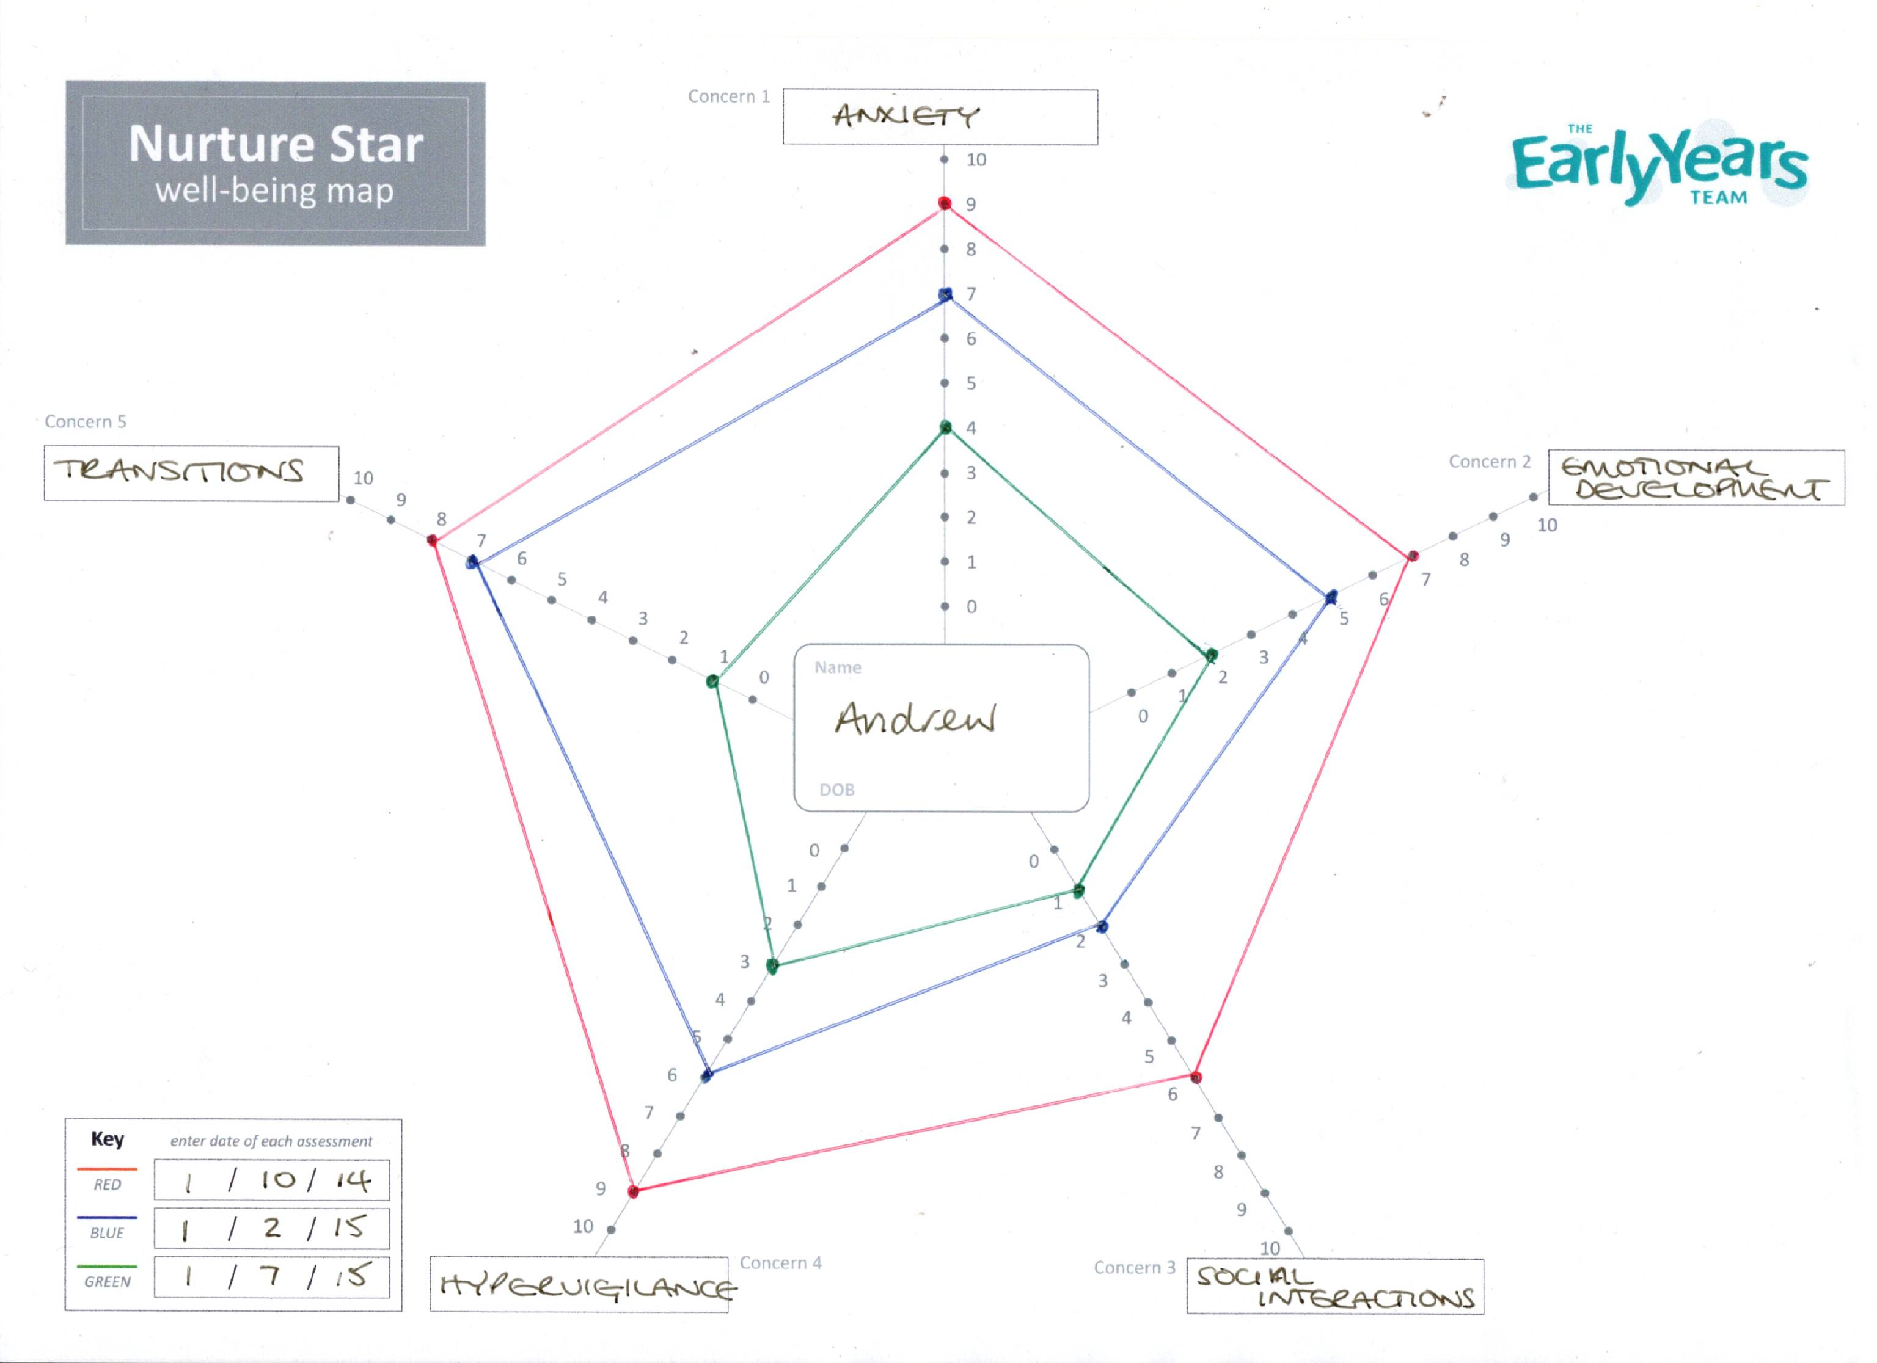

IDENTIFYING SOCIAL AND EMOTIONAL NEEDS

Child’s name |  | Date

Area of need | Information (continue on new page if needed)
High levels of anxiety.

A strong need to feel in control of situations.

Delays in emotional development where their skills and abilities are similar to those of a much younger child.

Differences in regulating their emotions, often needing an adult to help them.

Withdrawal from certain situations through being quiet and not engaging with activities, other children or adults.

Differences interacting with other children.

Hypervigilance, constantly looking around at what is going on in the setting without being able to properly settle to an activity.

A poor sense of self, not feeling positive about themselves or their achievements.

Anxiety during periods of transition.

Other

Child's name: ..............................................
Key Adult's name: .....................................
DOB: ..............................................
Date: ..............................................

Anxiety  Strategies to reduce levels of anxiety | Attention  Strategies to meet the need for attention | Adult  Strategies for key adult/s | Area Strategies for creating a safe place and areas
Calming activities - a special box of activities e.g. stress ball, positive touch  Adults to recognise the signs of increased anxiety e.g. twitching, increase in volume of voice | Reassurance that they will still be liked even if they have done something inappropriate  Finding ways to 'check-in' frequently  e.g. a touch on the shoulder, a reassuring  word | Identifying a safe person  Indirect praise e.g. X will really like the colours that you used on the picture  Adults to remain calm and contained | Social Stories for preparation of new situations  Visual timetable  Preparation for change  Clear routines
Transitional object - a favoured object from home  A cold/warm drink | Providing an area of responsibility in the classroom | Support/supervision for the 'safe person' to ensure containment and opportunities to talk about their work | Now and Next whiteboard  Safe place (in and out of class)

Child's name: ..............................................
Key Adult's name: .....................................
DOB: ..............................................

Date: ..............................................

Anxiety  Strategies to reduce levels of anxiety | Attention  Strategies to meet the need for attention | Adult  Strategies for key adult/s | Area Strategies for creating a safe place and areas

