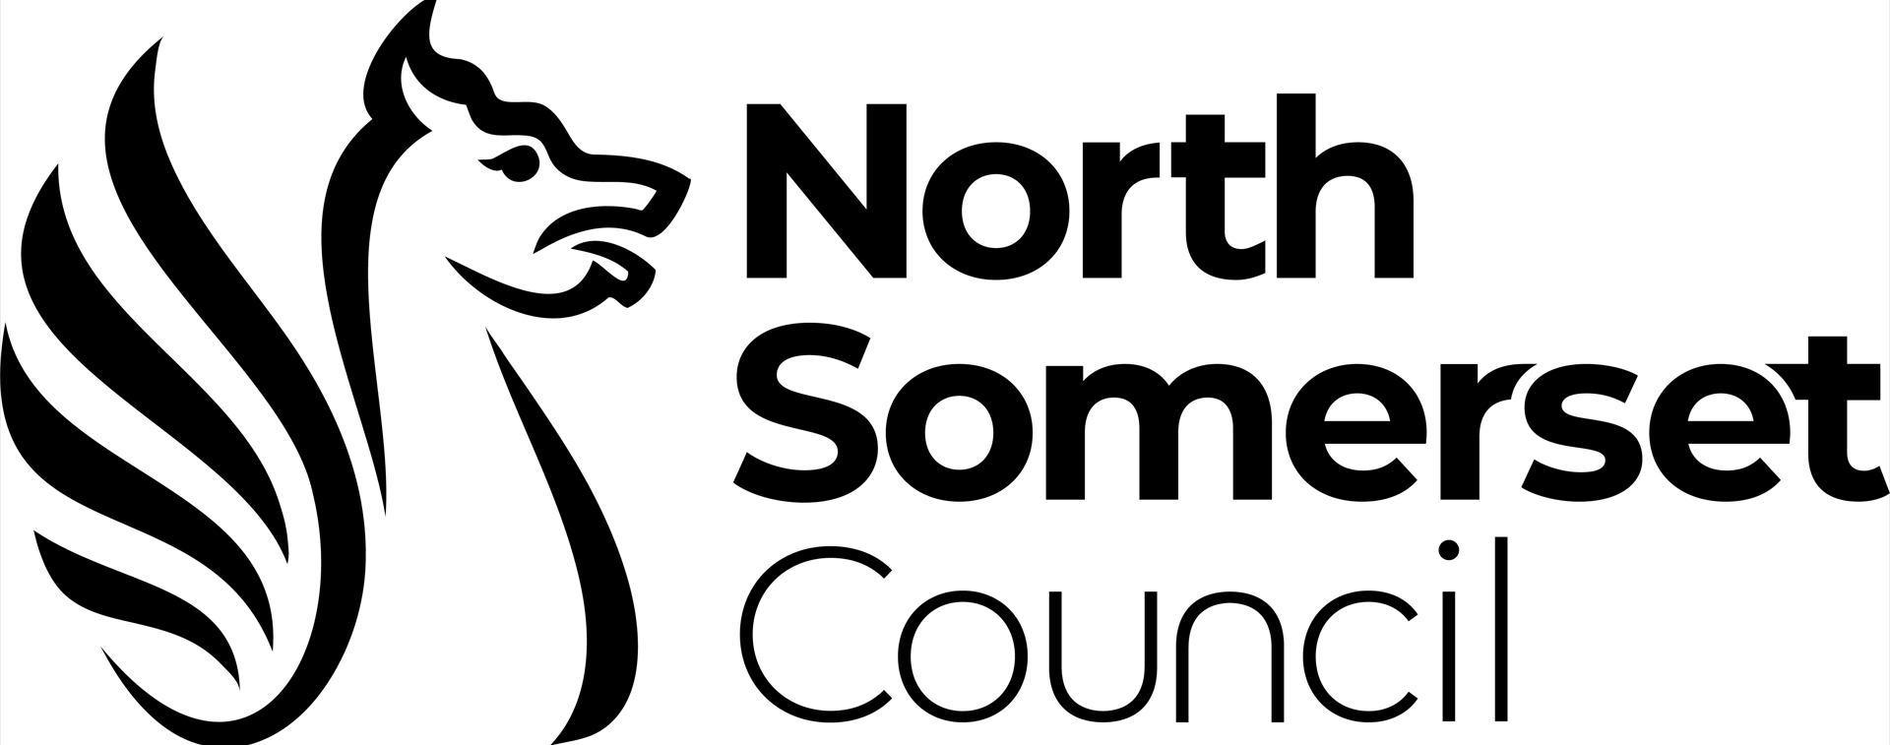

The Representation of the People Regulations 2001

REQUEST FOR A FREE COPY OF
THE FULL REGISTER OF ELECTORS

Candidate:

Parish / Parish Ward:

I request a copy of the Full Register of Electors for the above ward for which I am standing for election on Thursday 4 May 2023

Please complete the table below by marking an X to indicate how you require the information.

 | PRINT | EMAIL
Ward Register – Full version
Postal voters list

I am entitled to these documents in my capacity as a candidate for the by election in the above Ward on Thursday 4 May 2023 and I understand it is an offence to pass on or use the information in these documents other than for the purpose for which they are provided. I may only disclose or make use of information contained in it that is not contained in the edited register in accordance with The Representation of the People Regulations 2001.

Signed

Dated

E-mail/Postal address for Register
Privacy notice
Everyone working for Electoral Services has a legal duty to keep and process information about you in accordance with the law.

The Electoral Registration Officer (ERO) and Returning Officer (RO) are data controllers who collect and use information about individuals to enable us to carry out specific functions for which we are responsible and to provide you with a statutory service.

We will keep records about you which maybe be written down (manual records), or kept on a computer (electronic records). Your details will be kept and updated in accordance with our legal obligations and in line with statutory retention periods.

If you would like to know more about how we use your information you can contact the Data Protection Officer at dpo@n-somerset.gov.uk. You can also complain to the Information Commissioner: https://ico.org.uk

