|  |
| --- |
| [Company name] |
| Flood Warning & Evacuation Plan |
| For Residential Developments (>10) |

|  |
| --- |
|  |

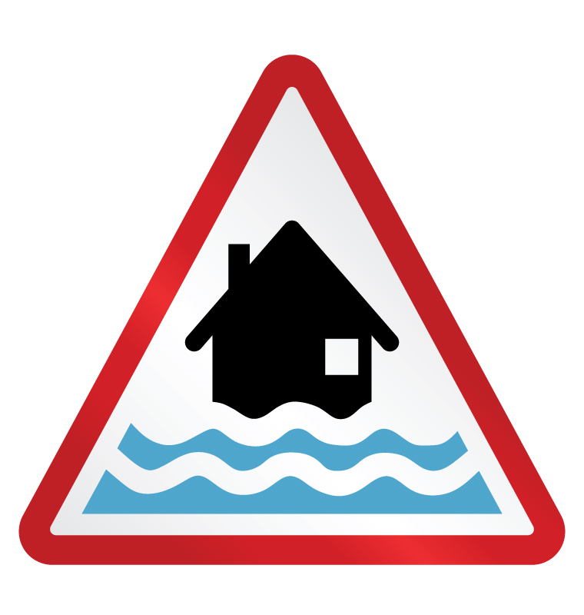

How to Use This Template

This template is designed for use by developers of larger (> 10) private residential housing. It adopts a practicable approach to meeting the requirements of the National Planning Policy Framework and PPS 25.

Each section of this template contains guidance [shown in red] which should be deleted prior to submission to North Somerset Council, Local Planning Authority for consideration.

# Document Control

This plan has been prepared by [insert company details] and [responsible officer] to inform residents of [enter name of development] on the joint responsibilities of the company and the homeowner to prepare for and respond promptly to flood warnings.

A copy of this plan will be made available to all homeowners:

* On first occupation; and
* In response to lessons learnt.

Plan Produced by:_____________________ Approved by:_________________________

## Version Control

|  |  |  |  |  |
| --- | --- | --- | --- | --- |
| Version No: | Comment | Checked by: | Approved by: | Date: |
|  |  |  |  |  |
|  |  |  |  |  |
|  |  |  |  |  |
|  |  |  |  |  |

# Disclaimer

North Somerset Council, as far as it can ascertain, acknowledges that this Flood Warning & Evacuation Plan (FWEP) template is suitable for the purposes set out within the national Planning Policy Framework. This plan is however the sole responsibility of the signatories and/or their representatives.

North Somerset Council cannot accept responsibility for any omission or error contained in any such plan, or for loss, damage, or inconvenience, which may result from the plans’ implementation. Any subsequent approval does not does not impute any approval of the plans from the Environment Agency or any of the emergency services.

Contents

Document Control i

Version Control i

Disclaimer i

Introduction 1

Objectives 1

Flood Risk 1

Annex A - Flood Risk Exposure 2

Appendix 1 to Annex A – Flood Risk Map 3

Evacuation 4

Warning & informing 4

Community & Household Resilience 4

Recovery 4

Annex B – Household Flood Warning Activation Procedures 5

Additional Guidance 6

# Introduction

This Flood Warning & Evacuation Plan (FWEP) has been produced by [name of organisation] in respect of the development known as [enter site name]. [Name of organisation] own the FWEP, are responsible for its implementation, dissemination and annual review.

The FWEP captures a summary of the site’s flood risk, taking into account flood mitigation measures incorporated in the design of the site and properties, and provides all relevant information, contact details and procedures to prepare for, respond to and recover from a flood event.

[Name of organisation] have given due regard to the safety of homeowners, responding organisations, available best practice, relevant legislation and advice provided by the emergency services, and the Emergency Management Unit of North Somerset Council.

# Objectives

In the production of this FWEP [name of organisation] have identified the following key objectives:

* To encourage residents to sign up to [Flood Warnings Direct](https://fwd.environment-agency.gov.uk/app/olr/home) and [Weather Warnings](http://www.metoffice.gov.uk/public/weather/warnings/);
* To encourage residents to develop household [flood plans](https://www.gov.uk/government/publications/preparing-for-emergencies/preparing-for-emergencies), which should include;
  + Identifying alternative accommodation.
* To encourage residents to join the Community Resilience North Somerset volunteer programme;
* To provide for and signpost clear evacuation routes for residents;
* To ensure adequate ingress and egress for the emergency services; and
* Reduce the risk to life and damage to property.

# Flood Risk

[North Somerset Council will expect this section to contain the following information]:

* Historical Flood data;
* A Flood Risk map (no smaller than A4) at a scale to provide sufficient detail and clarity;
  + Site plan / footprint of premises;
  + Ingress / egress;
  + Evacuation route and;
  + External place of refuge.
* Source(s) of flood risk;
* Warning systems in place;
* Estimated Flood Depth, frequency / probability; and
* Soft measures households may employ to further mitigate flood risk.

All of this information can be captured using the template at Annex A.

## Annex A - Flood Risk Exposure

|  |  |  |  |  |
| --- | --- | --- | --- | --- |
| **Historical Flood Data: (Attach Flood Risk Map as Appendix 1 to Annex A).** | | | | |
| **Flood Risk Source:** | **Warning Systems in Place**  **(Flood Warnings Direct etc.)** | **Estimated Flood Depth** | **Frequency / Probability** | **Site and Property Defence Measures**  [This section should be used to record all the measures adopted to reduce site and property level flood risk]. |
| **Fluvial:** |  |  |  |  |
| **Tidal:** |  |  |  |  |
| **Ground Water:** |  |  |  |  |
| **Surface Water:** |  |  |  |  |
| **Other:** |  |  |  |  |

### Appendix 1 to Annex A – Flood Risk Map

# Evacuation

The decision to evacuate or take shelter ultimately rests with the householder, but must be made to allow sufficient time to conduct the evacuation before flooding occurs. Flood waters contain hidden dangers and will impede, if not prevent, a safe evacuation.

Where you ae unable to identify or access alternative accommodations a safe place of refuge has been identified:

[Insert Name, Post Code & small map showing venue and evacuation route]

Your considerations should include:

* Identification of a venue suitable for the numbers and vulnerabilities of your residents; and
* 24/7 Access to said venue.

You are advised not to assume that the emergency services will be able to assist you with the evacuation; their focus will be directed to those in greatest need.

Where evacuation is not a feasible option, or has been delayed, you should move to the upper floor of the property; taking with you any important documents, bottled water, essential medicines and food sufficient to support you until rescue (see information related to [Grab Bags](https://www.gov.uk/government/publications/preparing-for-emergencies/preparing-for-emergencies)).

# Warning & informing

North Somerset Council and the emergency services encourage you to sign up to Flood Warnings Direct (FWD) from the Environment Agency and to Weather Alerts from the Meteorological Office and to act upon the guidance provided.

Annex B provides the means to record your planned actions in relation to the flood alert levels. Alternatively you may wish to make an [emergency plan](https://www.gov.uk/government/publications/preparing-for-emergencies/preparing-for-emergencies) for your home.

Community & Household Resilience

The successful implementation of any plan is dependent on all occupants being familiar with its content and to have rehearsed, where possible, the procedures contained within it. Rehearsing the plan can be made fun and educational for younger members of the family.

Resilience is achieved when individuals and communities cooperate to prepare for, respond to and recovery from emergencies. This begins with engagement with neighbours, understanding your community and culminates in a collective approach to management of risk.

You are encouraged to explore and consider joining Community Resilience North Somerset.

Recovery

If your home is subjected to flooding, and you have evacuated, you may not be allowed to return to your home until it has been declared safe to do so. Your insurance company will provide further guidance and support.

In the event that you did not evacuate it is possible that you will now be encouraged to do so, insurance companies may insist upon it in order to ensure your protection and to effect necessary repairs.

Annex B – Household Flood Warning Activation Procedures

|  |  |  |  |  |
| --- | --- | --- | --- | --- |
| **Warnings** | | **EA Recommended Actions** | **Household Actions** | |
| **Actions**  [Detail the actions you will take at each stage of the activation] | **Resources**  [Record the flood resources available and when you will deploy/utilise them] |
|  | **What it means:**  Flooding is possible.  Be prepared.  **When it’s used:**  Two hours to two days in advance of flooding. | Be prepared to act on your FWEP.  Prepare a flood kit of essential items.  Monitor [local water levels](http://www.environment-agency.gov.uk/homeandleisure/floods/riverlevels/default.aspx) and the flood forecast on our website. |  |  |
|  | **What it means:**  Flooding is expected.  Immediate action required.  **When it’s used:**  ½ an hour to one day in advance of flooding. | Move family, pets and valuables to a safe place.  Turn off gas, electricity and water supplies if safe to do so.  Put [flood protection equipment](http://www.environment-agency.gov.uk/homeandleisure/floods/31644.aspx) in place. |  |  |
|  | **What it means:**  Severe flooding.  Danger to life.  **When it’s used:**  When flooding poses a significant threat to life. | Stay in a safe place with a means of escape.  Be ready should you need to evacuate from your home.  Co-operate with the emergency services.  Call 999 if you are in immediate danger. |  |  |
| **EA Flood Warnings**  **No longer in force** | **What it means:**  No further flooding is currently expected in your area.  **When it’s used:**  When river or sea conditions begin to return to normal. | Be careful. Flood water may still be around for several days.  If you’ve been flooded, ring your insurance company as soon as possible. |  |  |
| **Meteorological Office**  **Weather Warnings** | Warnings of heavy rainfall.  Warnings of severe winter weather e.g. hail, snow, freezing rain. | Consider the impact of this type of weather – e.g. this could lead to surface water flooding, ground water flooding, increased river and sea levels. |  |  |

**SIGN UP TO FLOOD WARNINGS DIRECT**

# Additional Guidance

**Gov.UK:** [Prepare for a Flood](https://www.gov.uk/prepare-for-a-flood/make-a-flood-plan)

**Gov.UK:** [Preparing for Emergencies](https://www.gov.uk/government/publications/preparing-for-emergencies/preparing-for-emergencies)

**Environment Agency:** [Flood Warnings Direct](https://fwd.environment-agency.gov.uk/app/olr/home)

**Meteorological Office:** [Weather Warnings](http://www.metoffice.gov.uk/public/weather/warnings/)

**North Somerset Council:**

[Local Planning Authority](http://www.n-somerset.gov.uk/my-services/planning-building-control/planning/)

[Emergency Management Unit](mailto:emu@n-somerset.gov.uk)