Road closure for a special event
application form

Use this form if you wish to apply for a road closure to accommodate a special community event under the Town Police Clauses Act 1847.

Please make sure you have read our ‘event organisers’ guide to closing a road’ document and the following notes before you fill out this form.

- We need a minimum of 12 weeks’ notice and certainly not less than 8 weeks’ notice to make a road closure under the Town and Police Clauses Act.
- Currently, there is no charge for the making of this type of order, however, this may be reviewed in the future.
- Before making an application, assuming there is time, we would strongly recommend that the event organisers discuss the proposals with the Police. This will save time as it is not always necessary to have a formal road closure.
- Under the terms of the legislation, we must be satisfied that it is necessary to close the road in order to facilitate the event.
- If there are a number of residents, businesses, bus/taxi companies which may be affected by the closure, the Council will require the event organiser(s) to consult with those parties and confirm in writing that they have done so.
- For all events that require a road closure order, the organiser(s) will be responsible for the provision of appropriate signs and barriers and are required to provide a ‘signing schedule’. Where possible this should consist of:
(a) a map indicating the extents of the closure points and diversion route. Positions of road closure/diversion signs, barriers, etc. should also be identified.
(b) a list describing the wording/size/colour of the road closure/diversion signs, barriers etc. to be used.
A copy of the most commonly used signs is attached to the end of this application form, for your reference. Any bespoke signs intended to be used and their locations should also be included on the map.
- Signs and barriers are available through most of the hire services providing adequate notice is given. If you do not know of any companies providing these signs, the Council is aware of local sign makers who can be contacted. We cannot, however, be held responsible for any disputes which may arise between the parties.
- All signs must conform to Traffic Signs Manual, Chapter 8.
- Any cost involved must be met by the organisers including requirements for marshals or stewards.
- The completed application form and signing schedule should be sent to us as soon as possible to the address shown on this form. We will then inform the emergency services, local affected parties and any utilities that need to be notified.
- If the police and/or we object to the proposals, we will not proceed with the order.
- If there are any objections from any other parties, the organisers should have discussions with the objector to try to reach a compromise solution. If a compromise is not possible, the issue must be placed before the council’s appropriate Executive Member who will decide whether or not the order should be implemented.
- If the order is made, the organisers will be required to arrange for copies of the order to be posted on the affected routes.
- Event organisers should be aware that during the closure there must be clear access at all times for emergency services vehicles in the execution of their duties. This closure will apply to all other vehicular traffic.
- Public liability insurance of at least £5m is needed for any event held on a public road and you must send evidence of your cover with your completed application.
As well as this completed form, you will also need to send us:
- a map with the closure in red and the alternate route in green
- a sign schedule
- copies of any letters sent to local residents and businesses
- evidence of your public liability insurance cover (for a minimum of £5m)
- a risk assessment

Return your completed form by email or to the address below. Please contact us if you have any enquiries about requesting a road closure.

email: streetworks@n-somerset.gov.uk
post: North Somerset Council Street Works Team, Town Hall, Walliscote Grove Road, Weston-super-Mare, BS23 1UJ
telephone: 01934 888 802

1. Applicant’s details
Name
Address
Postcode
Telephone number
Email address

2. Details of the event and proposed road closure
Name of event
Nature and purpose
Date(s) of required road closure
Time of closure
Roads to be closed
Alternative route
Please include a map with the closure in red and the alternate route in green.
Please also include a map with a sign schedule – please use reference numbers for signs as shown at the end of this form.

3. Conditions of this application
I understand that I must comply with the following conditions:
1. Inform local residents and businesses affected by the proposed closure and diversion as soon as possible and send you copies of any letters I issue.
2. Provide signs and barriers as requested by the Street Works team (you will be advised if this requirement differs from your signing schedule).
3. Provide NRSWA accredited stewards, wearing appropriate reflective clothing.
4. Maintain access at all times for emergency services.
5. Provide evidence of public liability insurance for a minimum of £5 million
I understand that North Somerset Council accepts no liability should an accident occur.

Signature |  | Date
Name

Signs for temporary road closures
(ref. Traffic Signs Regulations and General Directions 2016)

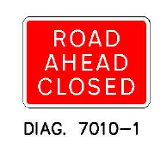  1 |  | 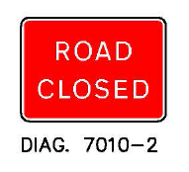  2
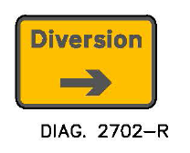  3 |  | 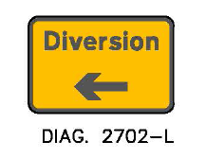  4
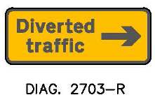  5a | 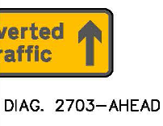  5b | 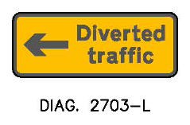  6
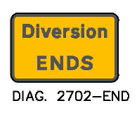  7 |  | 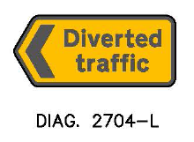  8
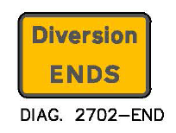  9 |  | 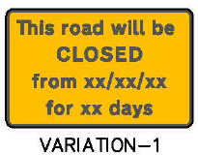  10a |  | 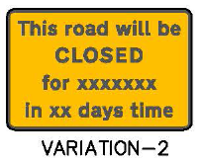  10b
Traffic signing  Temporary road closures |  | Scale | Date |  | Drawn
 |  | NTS | Oct ‘17 |  | EM
Notes
All signs are made using class 2 material.
Sizes are variable depending on road type and speed.

